Beaconhill Primary School Music

In music the children will perform, listen to, review and evaluate music from different periods of history and countries. They will use their voices and instruments to compose music of their own and perform in front of others. The children will explore how music is created, including having an understanding of pitch, duration, dynamics, tempo, timbre, texture, structure and notation.

A musician at Beaconhill Primary School should have:
- A widening repertoire which they use to create original, imaginative, fluent and distinctive composing and performance work.
- A musical understanding underpinned by aural perception, internalisation and knowledge of music, including high or developing levels of technical expertise.
- Good awareness and appreciation of different musical traditions and genres.
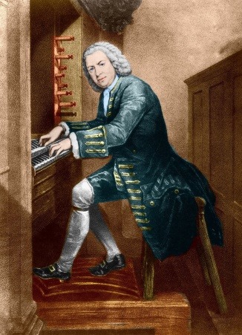
- An understanding of how musical provenance- the historical, social and cultural origins of music – contributes to the diversity of musical styles.

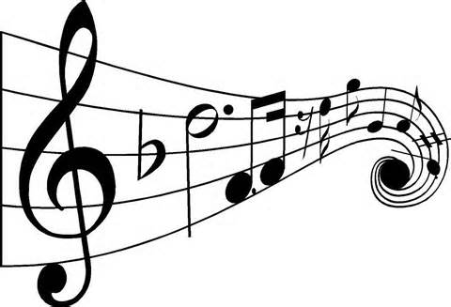
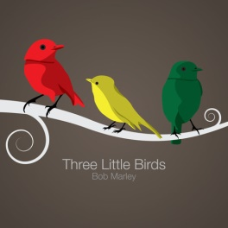
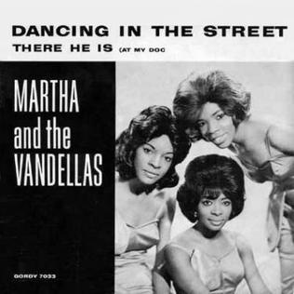
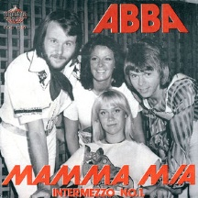
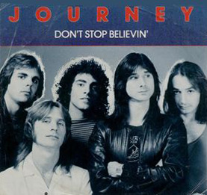

Music Overview
This curriculum map ensures that skills, knowledge and understanding are developed systematically across a subject.
 | Autumn 1 | Autumn 2 | Spring 1 | Spring 2 | Summer 1 | Summer 2
Year 1 | Beat, Rhythm and Pitch.  How Does Music Tell Us Stories About The Past? |  | Introducing Tempo and Dynamics.  How Does Music Make The World A Better Place? |  | Combining Pulse, Rhythm and Pitch  How Does Music Help Us Understand Our Neighbours?
Year 2 | Exploring Simple Patterns  How Does Music Help Us To Make Friends? |  | Focus on Dynamics and Tempo  How Does Music Teach Us About The Past? |  | Exploring Feelings Through Music  How Does Music Make The World A Better Place?
Year 3 | Enjoying Improvisation  What Stories Does Music Tell Us About The Past? |  | Composing Using Your Imagination  How Does Music Make The World A Better Place? |  | Djembes  Learning and instrument
Year 4 | Combining Elements to Make Music  How Does Music Connect Us With The Past? |  | Creating Simple Melodies Together  How Does Music Teach Us About Our Community? |  | Connecting Notes and Feelings  How Does Music Shape Our Way Of Life?
Year 5 | Getting Started with Music Tech  How Does Music Bring Us Together? | History of Music  Baroque Period | Exploring Key and Time Signatures  How Does Music Make Improve Our World? |  | Identifying Important Musical Elements  How Does Music Connect Us With The Environment?
Year 6 | Recorders  Learning an Instrument |  | History of Music  Classical and Romantic Periods | Developing Melodic Phrases  How Does Music Bring Us Together? | Understanding Structure and Form (Further Notation)  How does music connect us to the past? | Using Chords and Structure  How Does Music Shape Our Way Of Life?  (3-6)

